## Darshan Nikam Date: 16/03/2024

### **Data Migration**

"Transferring Netflix Movies and TV Shows Dataset from Local Computer to AWS RDS Instance Using MySQL Workbench"

In this Practice, I will transfer data from my local computer to an Amazon Web Services (AWS) Relational Database Service (RDS) instance. The dataset used for this task is downloaded from the internet and is in CSV format, containing information about movies and TV shows available on Netflix.

1. Create EC2 Instance and RDS Instance

Create an EC2 Instance:

* Launch an EC2 instance with the required configuration.
* Ensure the security group allows SSH (port 22) access from your IP address.
* Connect to your EC2 instance using SSH.
* install mariadb 10.5

Create an RDS Instance:

* Navigate to the RDS service in the AWS Management Console.
* Launch a new RDS instance with the MySQL engine.
* Configure the security group to allow MySQL/MariaDB (port 3306) access from the EC2 instance's security group.
* Note down the RDS endpoint, database name, username, and password.
* We need to make the DB instance public. To access it on MySQL.

1. Download MySQL WorkBench.
2. Open the MySQL.

* Click On the database option and select connect to database.

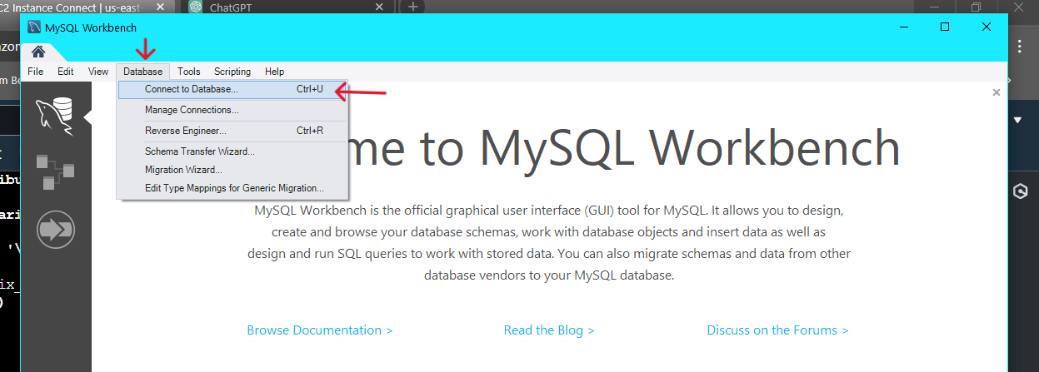

* In the hostname put the End point of the DB instance, enter the user name of the DB instance, and click on ok.

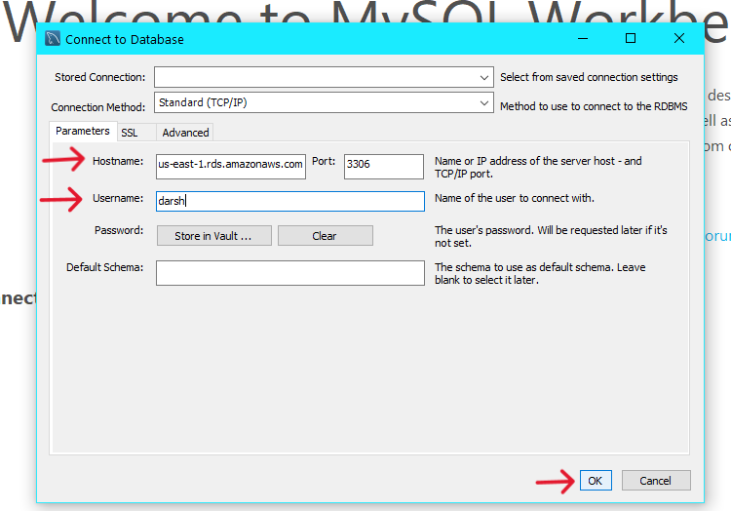

* Enter the DB Instance password and connect the DB Instance.

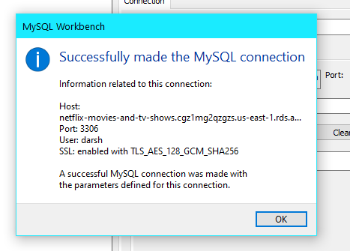

* Run the query to create the database

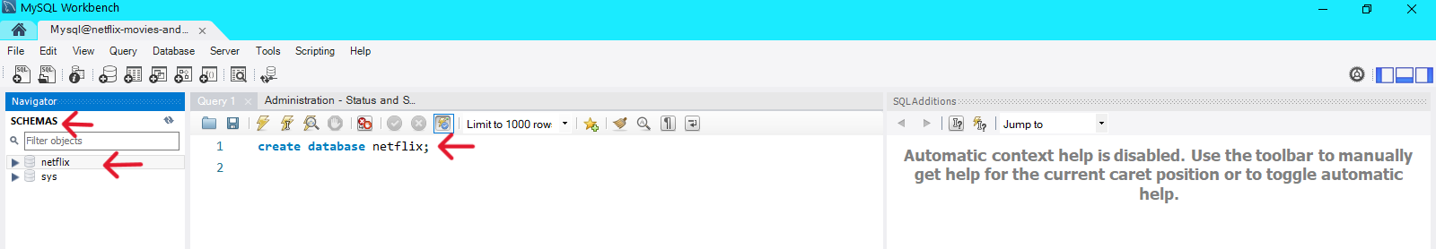

* Right side of the screen select the schemas option, right-click on the database name, and select the option Table Data Import Wizard.

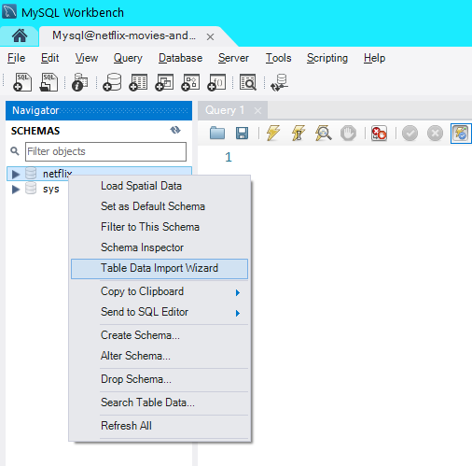

* Select the CSV file and click on the next button.

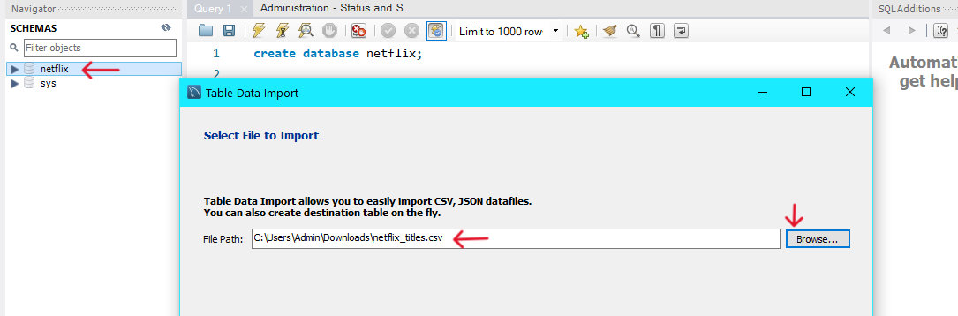

* Select the Create New Table option and enter the Table name that you want. Click on next.

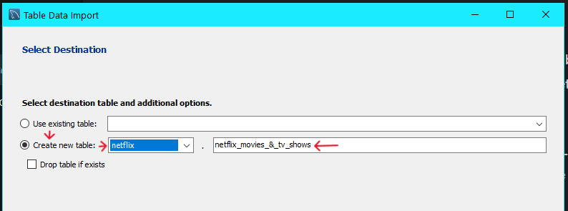

* Leave configure setting as it is. Click on next.

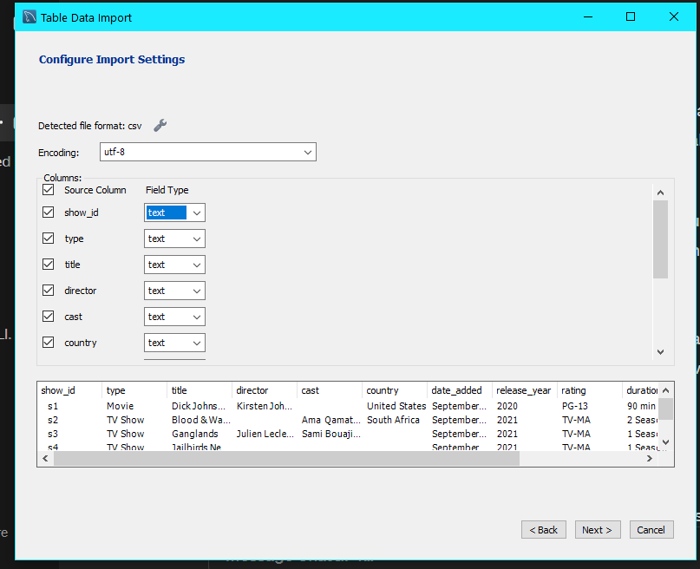

* Data Importing will start

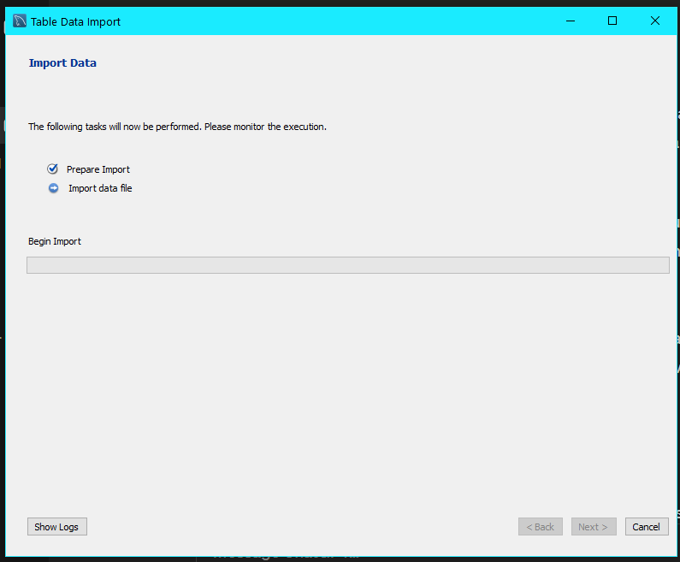

* Wait for it to complete.

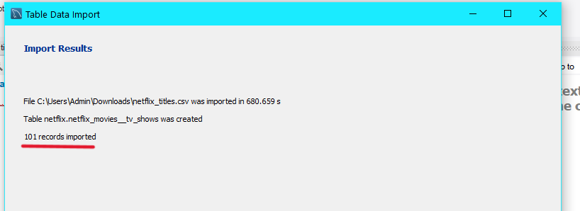

* Now data import is done

1. Go to the Ec2 Instance CLI and Connect to the DB Instance.
2. Now check the database and table

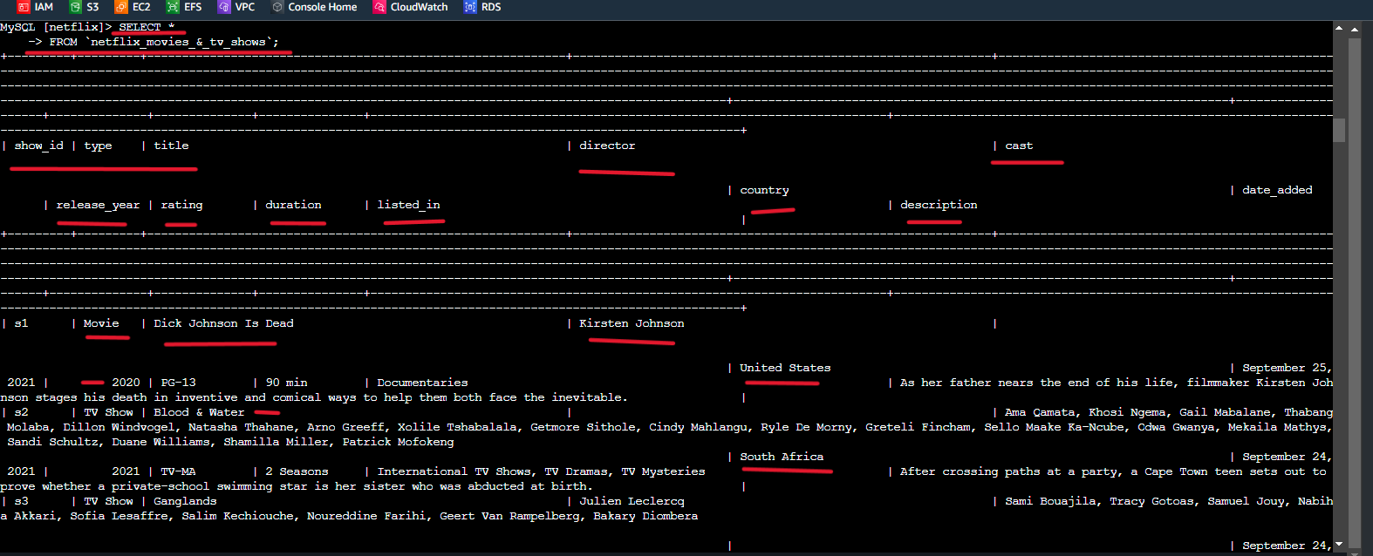

Here we can see our CSV file data is uploaded to RDS.